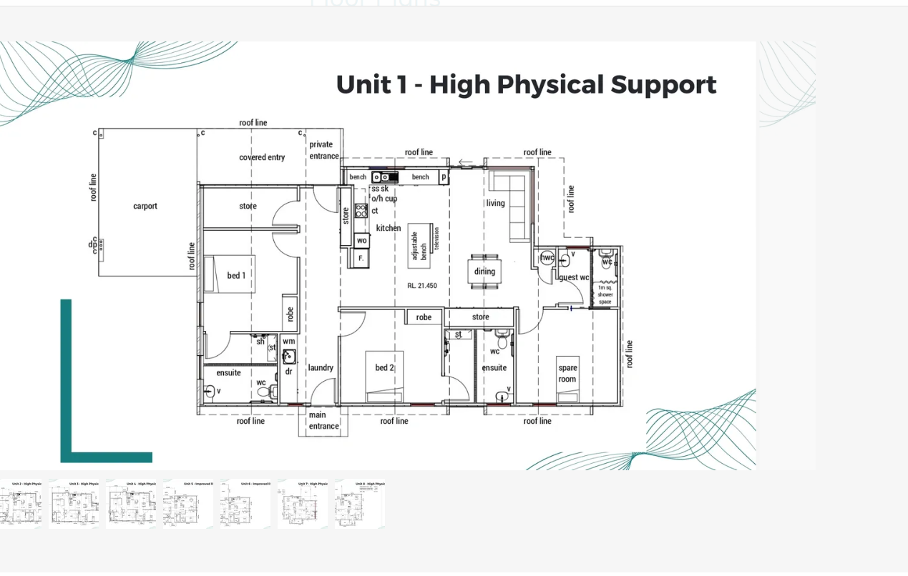

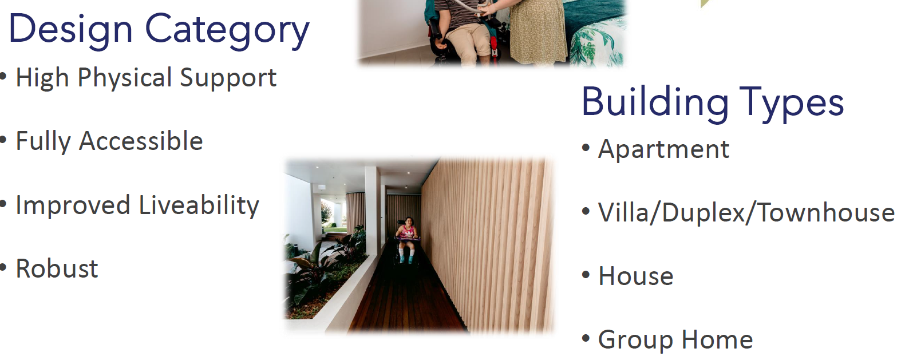

**Participant FN rent = $347.68**

SDA: per annum See SDA price calculator –

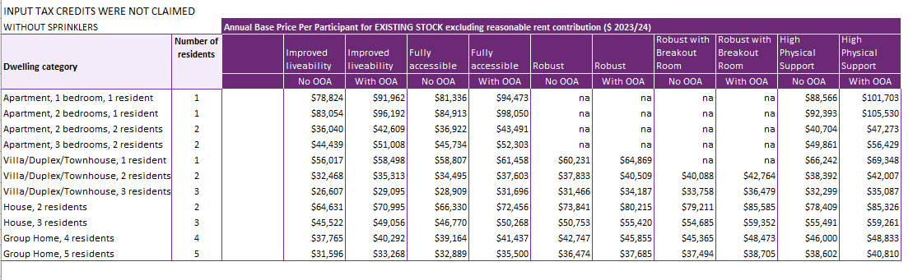

**House 3 residents w/OOA:**

IL = $48,831

FA= $ 50,268

HPS= $59,261

R= $59,352